READ ME

There is only one make file for both server and client.

**make -f make_webserver_clt**

above command compiles server and client both.

**make -f make_webserver_clt clean**

above command removes all the client object files created.

**cd <directory>**

above command changes the directory where files are present.

This is a basic web client and server model. Server waits for connection, reads and parses the HTTP GET request, returns the file requested. Code follows standard HTTP/1.0. Server sends both header and data in response.

Client Filename: **webclient.c**

Server Filename: **webserver.c**

* Open two terminals and change the directory if applicable.
* Run the mentioned make file for server and client in their terminals respectively.
* There are following scenarios for which the code was checked.

1. **Web client requesting the web server:**

Open two terminals, in one terminal start the web server by running the below mentioned command.

**./server 127.0.0.1 /home/nikhil246/Desktop/ 8000**

In other terminal start the client by running the below mentioned command.

**./clt 127.0.0.1/students.txt 8000**

Screenshots:

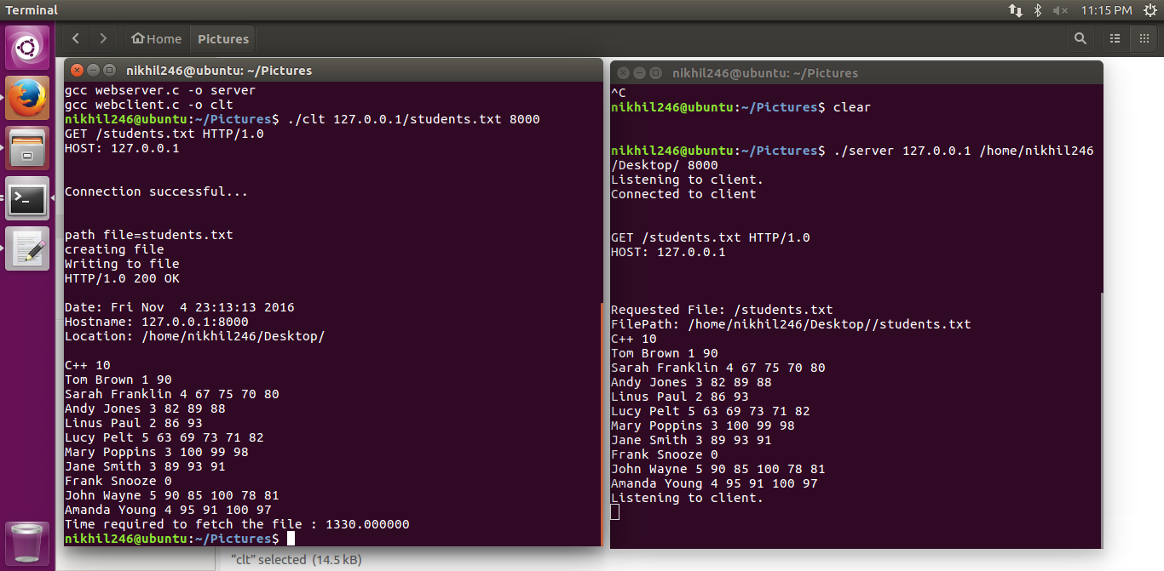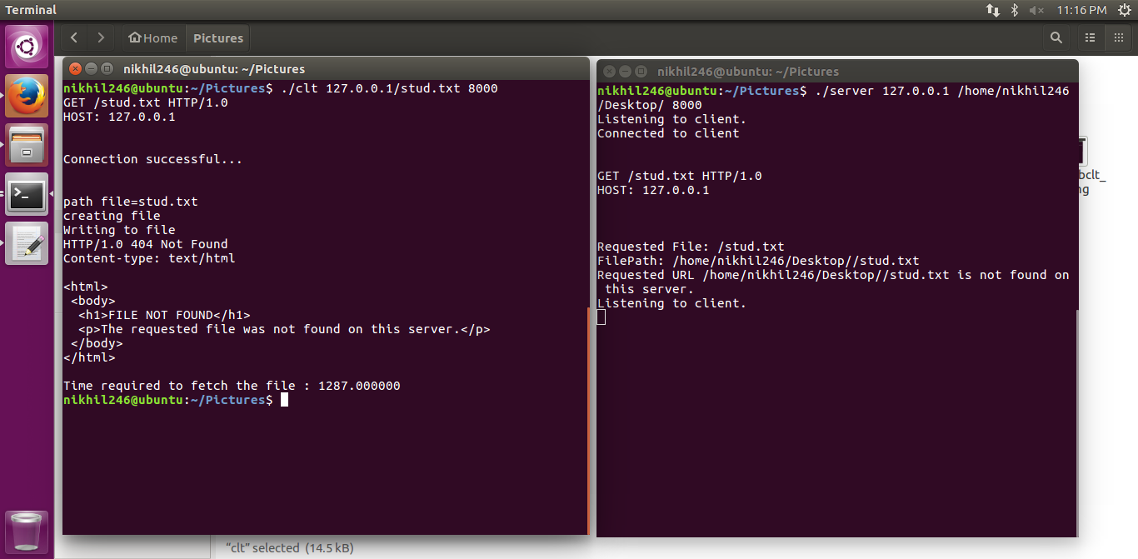

1. **Standard browser acting as a client requesting the web server:**

Open the browser and enter the following URL requesting the file. If file is present at the directory mentioned while starting the server it returns the file contents along with the header information and is displayed on the browser.

**localhost:8000/students.txt**

Before requesting the file from browser start the server by running the below command in one terminal.

**./server 127.0.0.1 /home/nikhil246/Desktop/ 8000**

Screen shots:

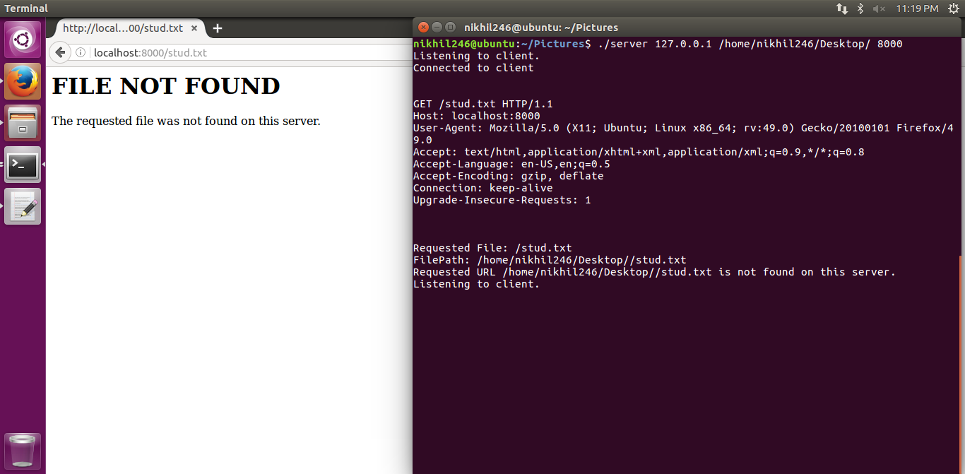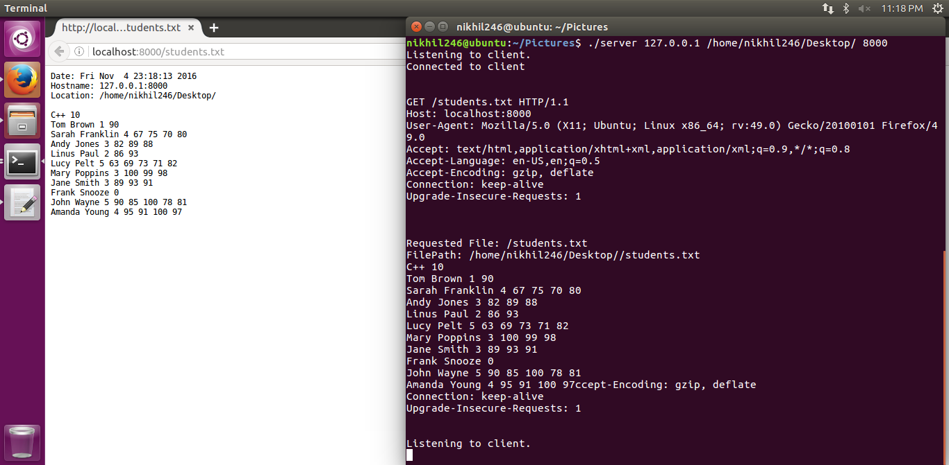

1. **Web client requesting the standard web browser:**

Start the client in one terminal by running the below command after compiling.

**./clt its.sjsu.edu/about/ 80**

Respective contents will be displayed at the client side. File will be created at the client side with contents. If file not found respective error message will be shown at client side as shown in screen shots.

